Draft email to parents and students….. feel free to edit as it pertains to your church, school, or ministry.

Greetings Parents & Students!

Preparing Students for College
Grades 10-12

As a church, we want to do everything we can to help your students become strong young adults as they prepare to transition from home to college and career. There is a movement to help all Christian high school students find and connect to campus ministries during their sophomore or junior college search, and their senior year college selection.

A Navigators study showed that connecting in advance, and the first 72 hours on campus, are key to success in faith. We’d like to see all our families plus churches in our area experience the blessing that is taking hold around the country…. The typical 70% faith drop-out is being reversed as students connect in advance to a vibrant campus ministry and church. Students return for Christmas energizing their families, schools, and youth groups with stories of growth, wonderful friends, and leading others to Christ.

You and your student can use the below link to watch powerful engaging videos, then take a 5-minute step to have your student log in and start searching for ministries to reach out to. We’d love to hear back from you when you’ve done this so that we can be sure the message is spreading.

www.BelieversCollegePrep.com/Start

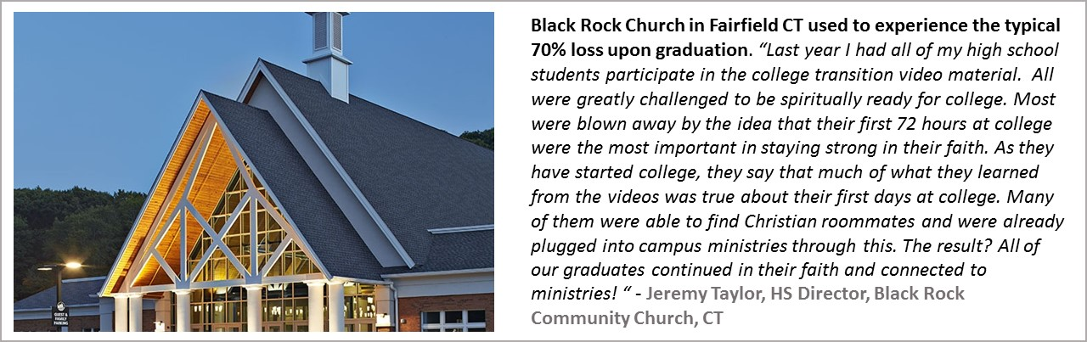

It would be wonderful if every church and Christian school in our city experienced this same blessing. We encourage you to share this with your friends and ministry leaders.

Let us know what you learn from this!

Blessings,

Pastor (or principal, etc) __________

