Greetings Parents & Students!

Helping All CNY Students Transition Well to College

As a church body, we want to do everything we can to help your students become strong young adults as they prepare to transition from home to college and career. There is a Central New York movement this Spring and Summer to help all area Christian high school students find and connect to campus ministries during their sophomore or junior college search and senior year college selection. See Link.

We’d like to see all families and churches in our area experience what is what is beginning to happen…. The 70% faith drop-out significantly reduced and students returning to youth groups for Christmas invigorating them with stories of growth, wonderful friends, and leading others to Christ.

You and your student can use the below link to watch powerful videos to engage them, and then take a 5-minute step to have them log in and start searching for ministries to reach out to.

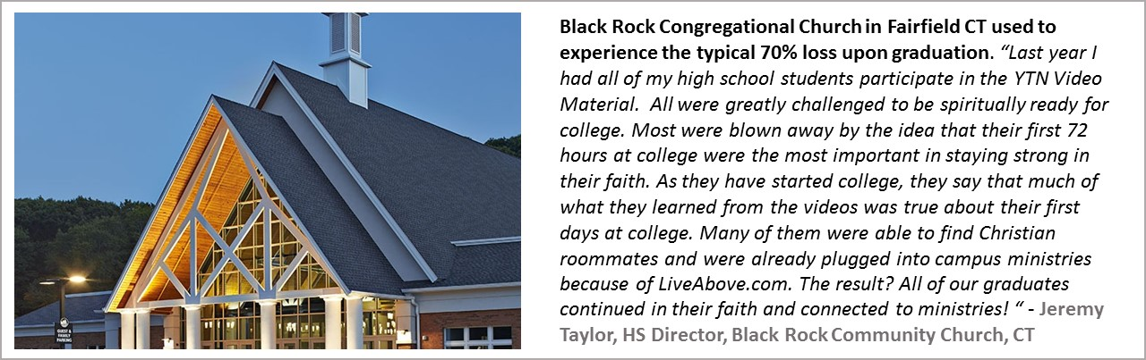

Minimizing Student Debt - You will also see videos at the end of the link to help you and your teen understand the dangers of excessive college debt and how to understanding the “business of college” and empower your family to be in the driver’s seat.

Syracuse area movement - Join other area high school students and parents for the Worship the King event at Syracuse University for an immersion into college ministry experience led by CRU, BCM, FCA, BASIC and other campus groups. Parents and students can come at 5PM for a special session by students and leaders on how to grow your faith in college. There is free parking behind Hendricks Chapel. The Chancellor will speak and is inviting the entire community. See the below link for details.

