Greetings Parents & Students!

Helping Students Succeed in College

Reversing the 70% Faith Drop-Out

As a church body, we want to do everything we can to help your students become strong young adults as they prepare to transition from home to college and career. There is a united church movement this Spring and Summer to help all area Christian high school students find and connect to campus ministries during their sophomore or junior college search and senior year college selection.

We’d like to see all families and churches in our area experience what is what is beginning to happen…. The 70% faith drop-out significantly reduced and students returning to youth groups for Christmas invigorating them with stories of growth, wonderful friends, and leading others to Christ.

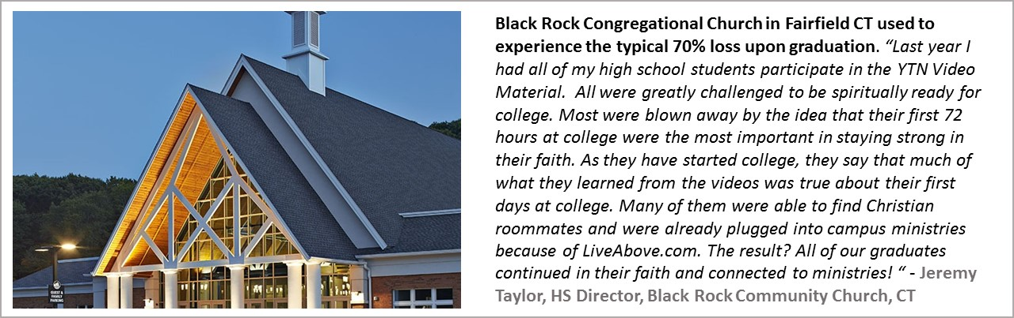
www.BelieversCollegePrep.com/Start

You and your student can use the above link to watch powerful videos to engage them, and then take a 5-minute step to have them log in and start searching for ministries to reach out to.

Rochester Area Movement and Events

Learn how churches are working to see that no student in our region is left behind. You can attend area events on April 24, May 1, and May 12. See www.BelieversCollegePrep.com/Rochester.

Reversing the Student Debt Crisis in Churches

You will also see videos at the end of the above links to help you and your teen understand the dangers of excessive college debt and how to understanding the “business of college” and empower your family to be in the driver’s seat.

Spreading the word – Please share this information and resources with any friends, leaders, and pastors you know so that next Christmas hundreds of area youth will return to energize their youth groups with stories of growth and leading others to Christ.

Blessings,

Your Family ministry team

