You can paste this all into an email, along with the hyperlinked images and modify as you wish. Just contact me at john@BelieversCollegePrep.com or 315-480-1232 if you have any questions - John Decker

Greetings,

You probably know that studies show that around 70% of Christian students who enter college walk away from the faith during that experience. Only about a third of these who walk away eventually return, that is after they have made most of their major life choices like a spouse and career. They also forfeit the opportunity to reach new freshmen for Christ.
It’s been proven that students in any church nearly always succeed when they are meaningfully connected to campus ministries during their junior college search and before graduation.
Rochester is poised to be one of the first cities where all the students are meaningfully connected in advance. The expectation is that when they return home for Christmas, instead of being cool to the faith will come with stories of the best friends they have ever made and helping lead students to faith. The below WZXV radio announcements share more.
We hope to get all the teens in our church connected, so I highly recommend that you watch the below 4-minute video and click on the images to help your son or daughter to start exploring and connecting with ministries through the database shown.
Information is below, including a regional event on March 6th which covers college transition as well as ways to avoid a crippling level of student debt. For more information you can contact John Decker (see info) at 315-480-1232 or john@BelieversCollegePrep.com.
Blessings,
Pastor____________
Click Image for Info
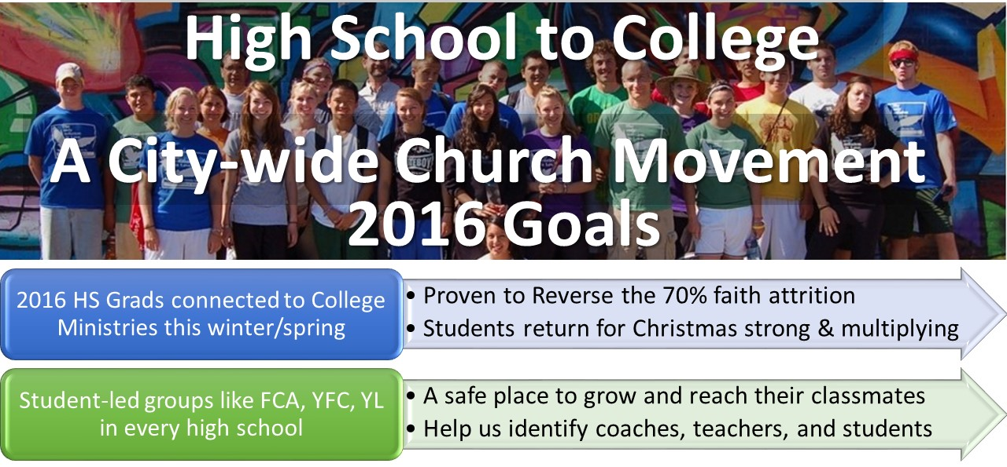

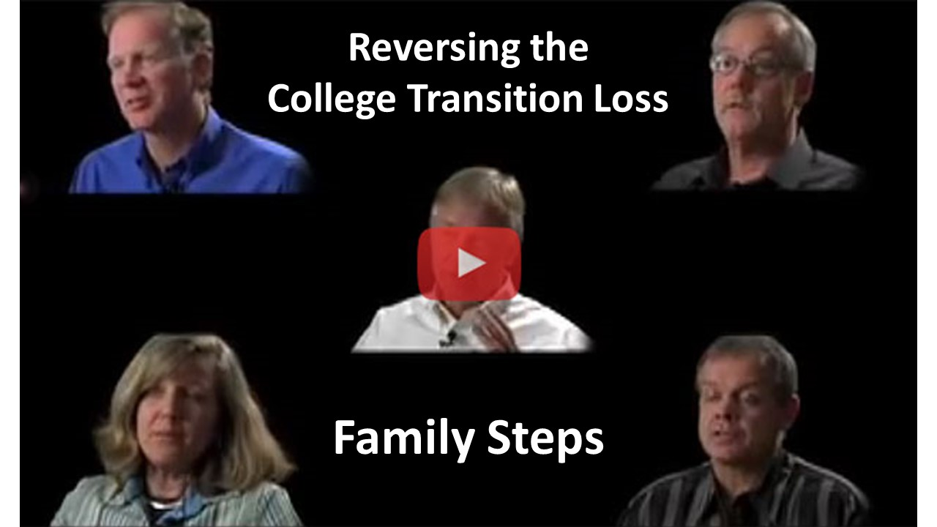

Calvary Chapel’s WZXV radio was interested in propelling the movement and has provided radio announcements you can hear on the bottom of this link.
For information, contact John Decker at john@BelieversCollegePrep.com or 315-480-1232
