Draft email to parents and students….. feel free to edit!

Greetings Parents & Students!

Preparing Students for College
Grades 10-12

As a church body, we want to do everything we can to help your students become strong young adults as they prepare to transition from home to college and career. There is a movement to help all Christian high school students find and connect to campus ministries during their sophomore or junior college search, and their senior year college selection.

A Navigator study showed that the first 72 hours on campus are key to success in faith. We’d like to see all families and churches in our area experience the blessing that is beginning in churches around the country…. The typical 70% faith drop-out is being reversed as students connect in advance to a vibrant campus ministry and church. Students return for Christmas energizing their families and youth groups with stories of growth, wonderful friends, and leading others to Christ.

You and your student can use the below link to watch powerful engaging videos to then take a 5-minute step to have them log in and start searching for ministries to reach out to. We’d love to hear back from you when you’ve done this so that we can be sure the message is spreading.

www.BelieversCollegePrep.com/Start

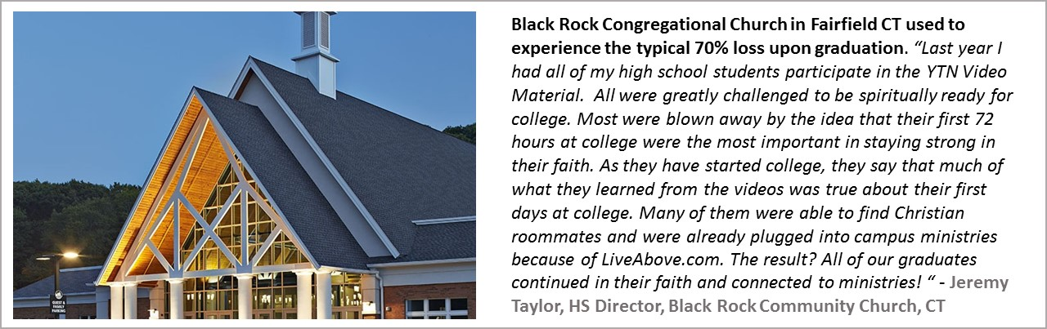

Minimizing Student Debt – Success in college means growing in your faith, finding the right viable career, and avoiding a crippling level of student loan debt that impacts so many graduates. You will see videos on www.BelieversCollegePrep.com that will help you and your teen grasp the dangers of excessive college debt and how to understanding the “business of college” to empower your family to be in the driver’s seat.

Let us know what you learn from this!

Blessings,

Pastor __________

